Lab 2: Agile Backlog Creation & Sprint Simulation in Jira

Project Name: Food Bank Surplus Redistribution Platform
Student Name: Pradyumn Bidari
SRN: PES1UG24AM194
Section: D
2. Epics and User Stories Table
Epic Name | User Story Summary | User Story Description (As a... I want to... So that...) | Priority | Story Points
Epic 1: User Onboarding & Verification | Story 1.1: Partner Registration & Verification | As a platform admin, I want to verify donor and shelter credentials, so that only authorized organizations can post or reserve food. | High | 5
 | Story 1.2: Role-based Authentication | As a registered user, I want to securely log in to my specific dashboard, so that I can access my role-specific tools. | Medium | 3
Epic 2: Surplus Food Listing Management | Story 2.1: Post Surplus Food Batch | As a donor partner, I want to post food listings with quantity, dietary tags, pickup address, and expiry time, so that shelters can evaluate the batch. | High | 5
 | Story 2.2: Automated Expiry Countdown | As a donor partner, I want to see an automated expiry timer on listings, so that expired batches are automatically deactivated. | Medium | 3
 | Story 2.3: Real-Time Shelter Notifications | As a shelter coordinator, I want to receive immediate alerts for nearby perishable food batches within 30 seconds, so that I can act before food spoils. | High | 5
Epic 3: Batch Reservation & Matching | Story 3.1: Browse & Filter Available Batches | As a shelter coordinator, I want to filter food listings by location, food type, and dietary tags, so that I find suitable meals quickly. | High | 3
 | Story 3.2: Reserve Food Batch & Window | As a shelter coordinator, I want to reserve an available batch and choose a pickup window, so that the food is locked for my shelter. | High | 5
 | Story 3.3: Manage & Cancel Reservations | As a shelter coordinator, I want to cancel a reservation if needed, so that the batch is released back to other shelters. | Low | 2
Epic 4: Pickup Verification & Order Traceability | Story 4.1: Pickup Verification Code Generation | As a shelter coordinator, I want to receive a secure verification code upon reserving, so that I can present it during pickup. | Medium | 3
 | Story 4.2: Pickup Confirmation & Logging | As a donor partner, I want to validate the shelter's code upon pickup, so that the transaction is logged as completed. | Medium | 3
 | Story 4.3: Redistribution History & Audit Log | As an administrator, I want to view audit logs of all pickups and reservations, so that donated food remains fully traceable. | Low | 2
3. Story Point Estimation & Planning Poker Write-up
- Planning Poker & Story Points: Story points are units of measure used to express the overall effort, complexity, and uncertainty of implementing a user story, rather than tracking raw hours. Planning poker was used as a consensus-based estimation technique to eliminate individual bias and align team understanding on task scope.
- Fibonacci Scale: Story points were assigned using the Fibonacci sequence (1, 2, 3, 5, 8). The non-linear growth of this scale accurately reflects the exponential rise in risk and uncertainty as tasks grow larger. For instance, complex architectural items like real-time notification dispatch and partner verification were estimated at 5 points, whereas straightforward tasks like reservation cancellations were estimated at 2 points.
4. Prioritization & Ranked Backlog
The product backlog was prioritized by placing high-business-value and critical functional requirements—such as user verification, posting batches, immediate notification dispatch, and batch reservations—at the top of the backlog. This ordering ensures the core Minimum Viable Product (MVP) workflow is delivered first, while secondary tasks such as audit logging and reservation cancellation are scheduled for later iterations.
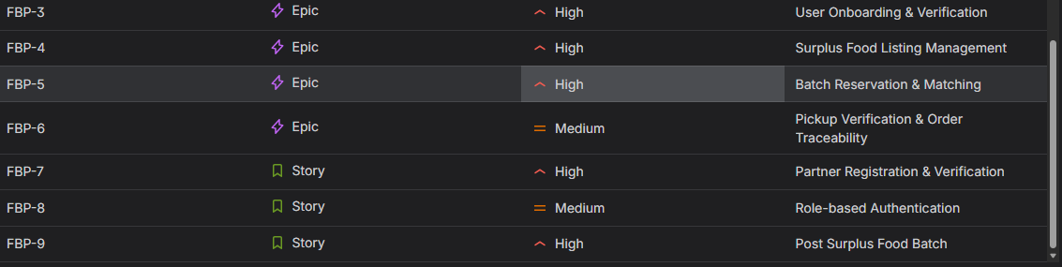
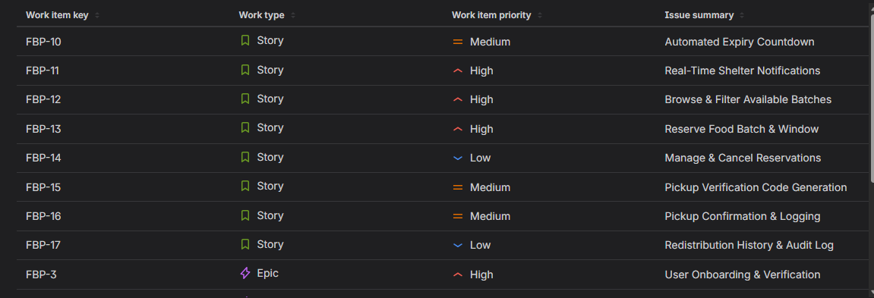
5. Sprint Simulation & Burndown Chart
- Sprint Execution: The project implementation was organized into time-boxed mock sprints with a 1-week duration. Work was tracked on an active Scrum board, transitioning user stories across To Do, In Progress, and Done states, accompanied by progress updates and comments.
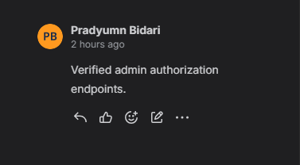
- Burndown Analysis: The Burndown Chart tracks remaining Story Points on the vertical axis against Sprint Timeline on the horizontal axis. The remaining work curve successfully burned down to zero alongside the ideal guideline, indicating that all committed velocity was achieved within the sprint duration.
SCREENSHOT 1: Burndown Chart from Reports
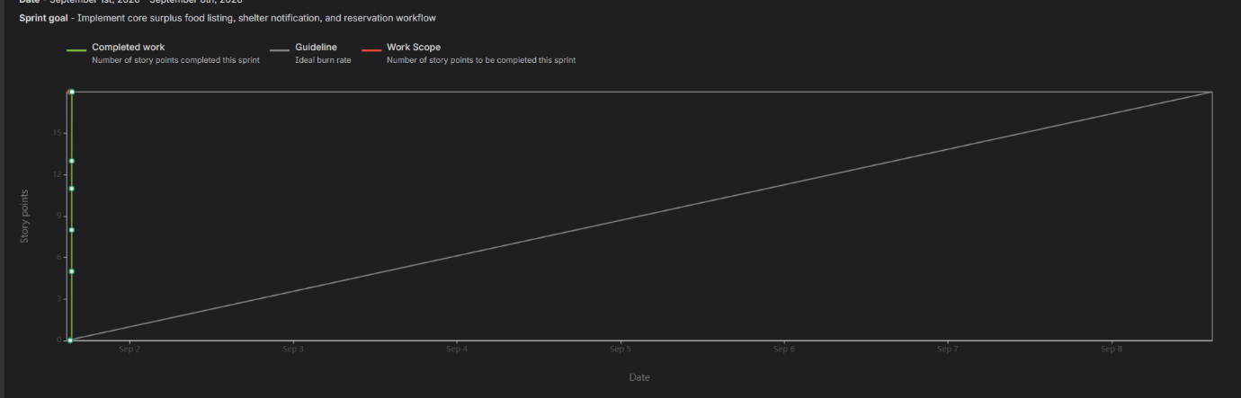
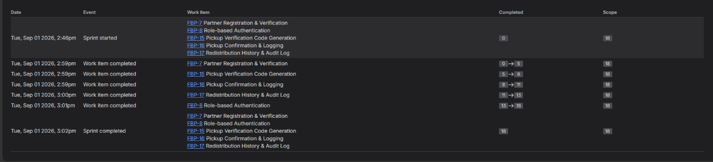
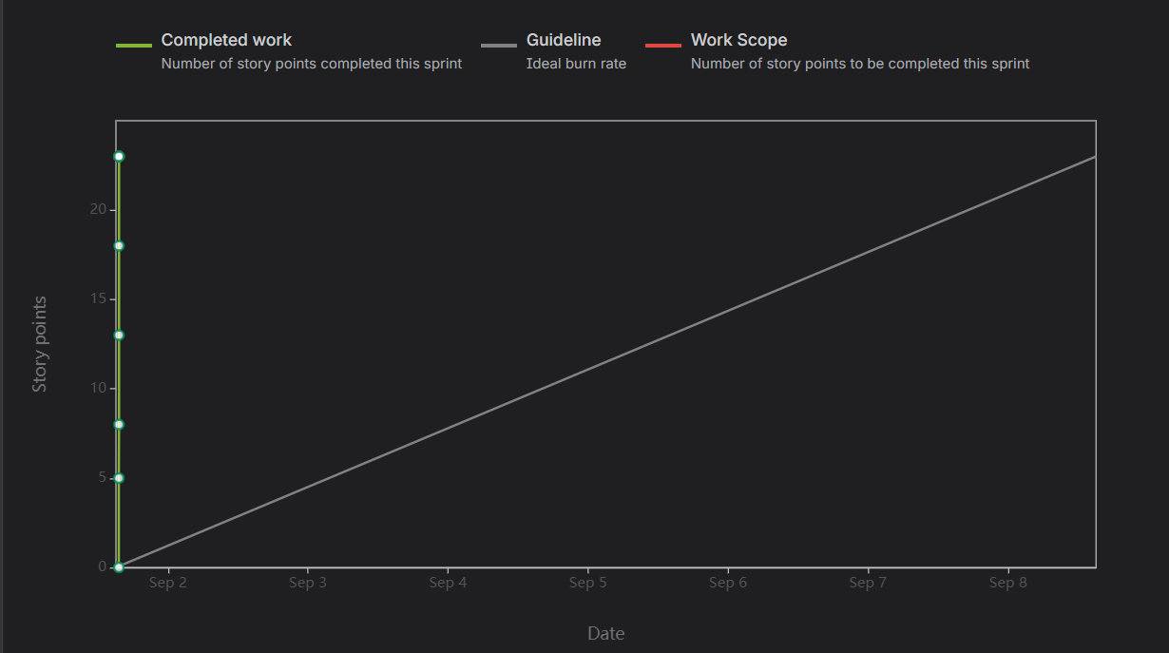
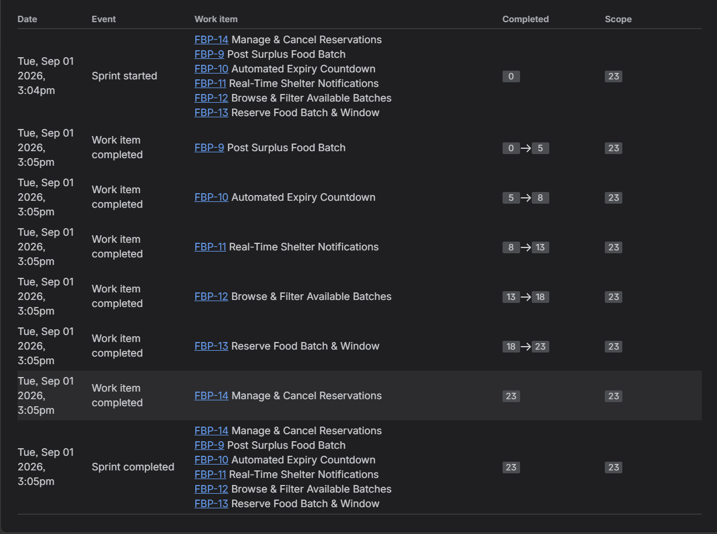
SCREENSHOT 2:SUMMERY 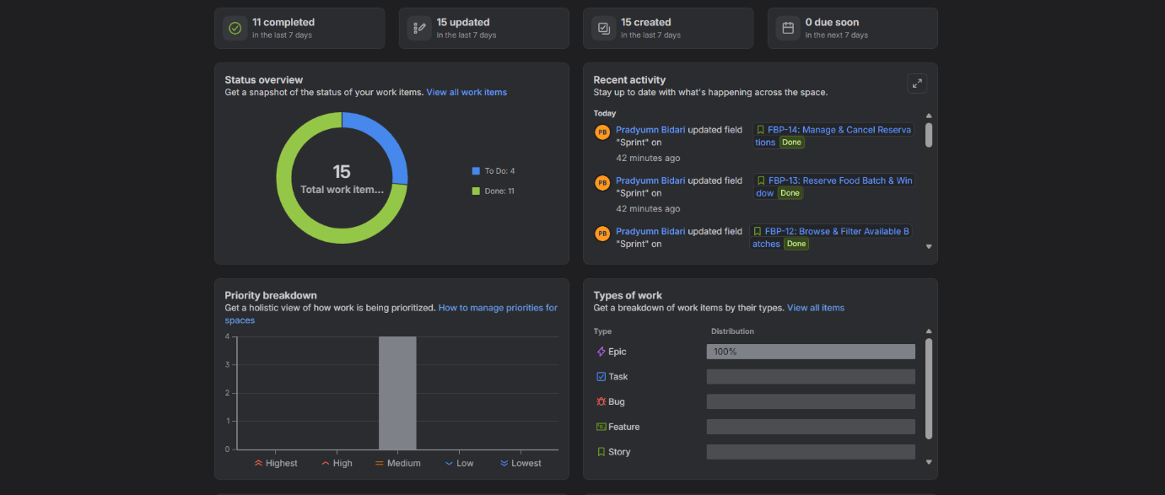
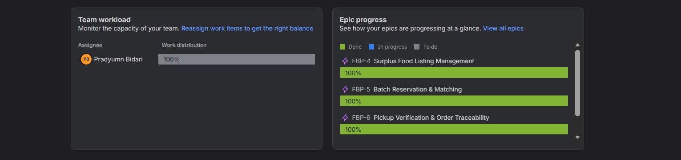
6. Reflection & Analysis
This sprint simulation demonstrated the practical workflow of Agile Scrum methodologies using Jira. Deconstructing high-level functional requirements into Epics and User Stories improved visibility into system boundaries and user roles. Tracking delivery through real-time artifacts such as the Burndown Chart and Summary dashboard offered essential feedback on team velocity, prevented scope creep, and validated the importance of iterative planning for predictable software delivery.

